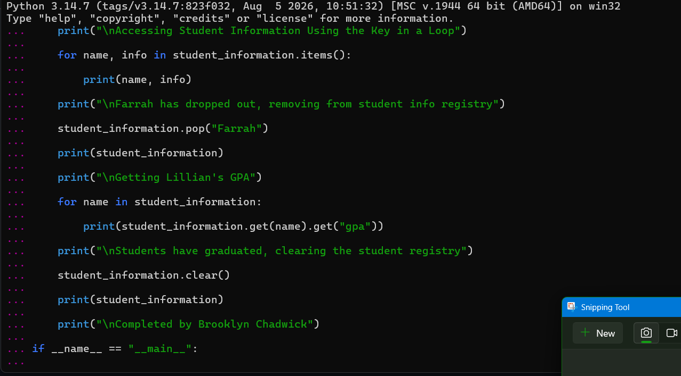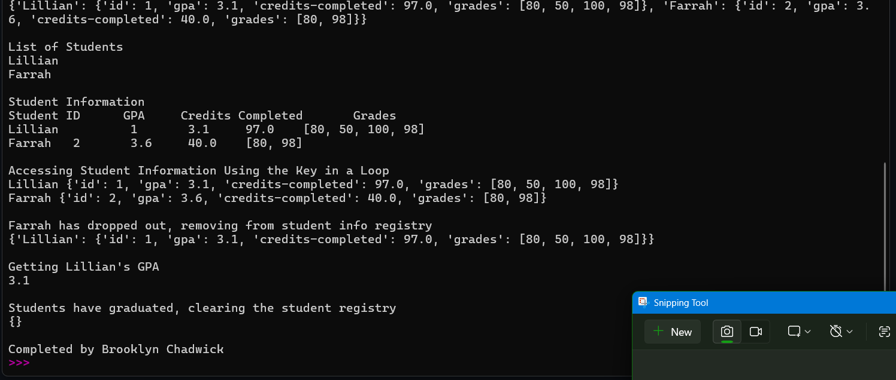

def main():
student_information = {}
student_information["Lillian"] = {
"id": 1,
"gpa": 3.1,
"credits-completed": 97.0,
"grades": [80, 50, 100, 98]
}
student_information["Farrah"] = {
"id": 2,
"gpa": 3.6,
"credits-completed": 40.0,
"grades": [80, 98]
}
print(student_information)
print("\nList of Students")
for name in student_information:
print(name)
print("\nStudent Information")
print("Student\tID\tGPA\tCredits Completed\tGrades")
for name, info in student_information.items():
print(name, "\t", info["id"], "\t", info["gpa"],
"\t", info["credits-completed"], "\t", info["grades"])
print("\nAccessing Student Information Using the Key in a Loop")
for name, info in student_information.items():
print(name, info)
print("\nFarrah has dropped out, removing from student info registry")
student_information.pop("Farrah")
print(student_information)
print("\nGetting Lillian's GPA")
for name in student_information:
print(student_information.get(name).get("gpa"))
print("\nStudents have graduated, clearing the student registry")
student_information.clear()
print(student_information)
print("\nCompleted by Brooklyn Chadwick")
if __name__ == "__main__":
main()

